**24 Books to Read in 2024**

Hello 2024! Make this your family’s most exciting year of reading. These books are perfect for bedtime, after school, breakfast or anytime in between. Happy reading!

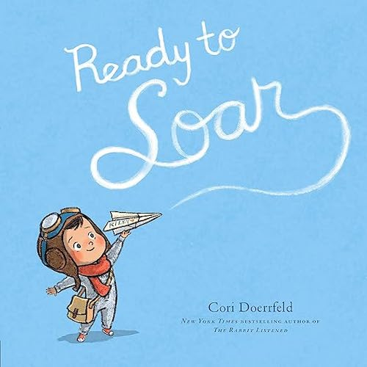

**Books for Infants**

* [The Old Truck](https://amzn.to/3NUHdVL) by Jerome Pumphrey
* [Big Babies](https://amzn.to/48MY44V) by Patrick P’Brien
* [Hippos Remain Calm](https://amzn.to/3HbluF2) by Sandra Boynton
* [Ready to Soar](https://amzn.to/48L4gKK) by Cori Doerrfeld
* [Like So](https://amzn.to/3H9KigF) by Ruth Forman

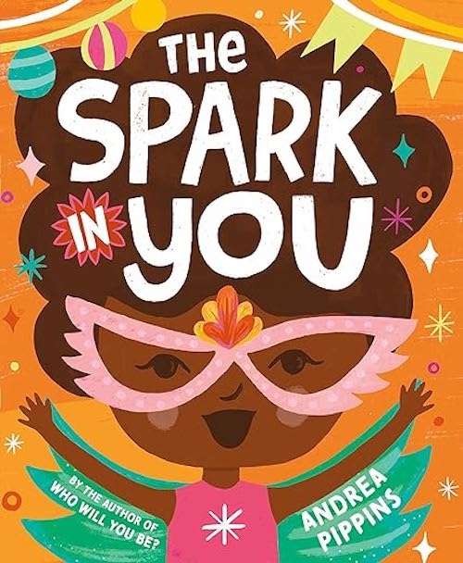

**Books for Toddlers & Preschoolers**

* [The Gingerbread Man Class Pet on the Loose](https://amzn.to/3TJw4e6) by Laura Murray
* [Buffalo Fluffalo](https://amzn.to/3TLgTRC) by Bess Kalb
* [Grumpy Monkey Spring Fever](https://amzn.to/3RKF00d) by Suzanne Lang
* [The Spark in You](https://amzn.to/47omErG) by Andrea Pippins
* [Sleepy Sheepy and the Sheepover](https://amzn.to/47roeJ6) by Lucy Ruth Cummins

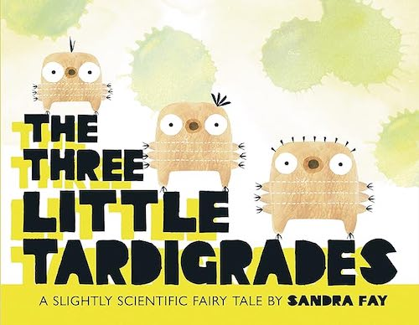

**Books for Elementary Schoolers**

* [Angela’s Glacier](https://amzn.to/3NSrpmr) by Jordan Scott
* [The Tree Little Tardigrades](https://amzn.to/3NVmwsF) by Sandra Fay
* [Alterations: A Graphic Novel](https://amzn.to/3tLbv6w) by Ray Xu
* [The Lost Library](https://amzn.to/3S60kP5) by Rebecca Stead
* [Tasty: A History of Yummy Experiments](https://amzn.to/4aKMAk4) by Victoria Grace Elliott

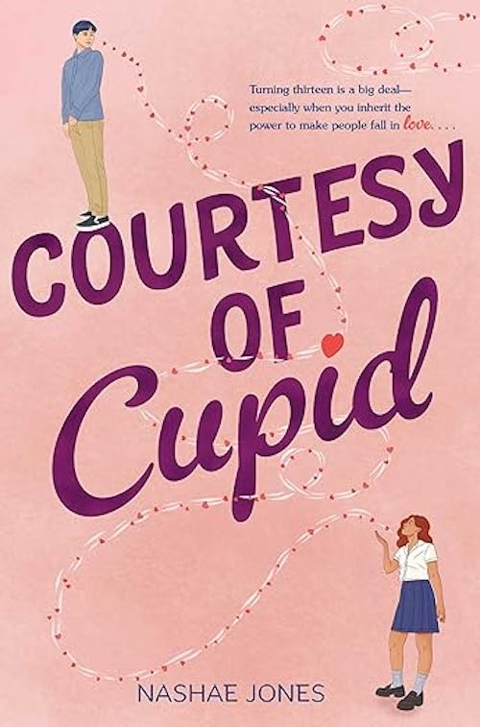

**Books for Tweens**

* [The Misfits #1: A Royal Conundrum](https://amzn.to/3SaPGqp) by Lisa Yee
* [What It’s Like to be a Bird](https://amzn.to/3SaPGqp) by David Allen Sibley
* [Slug Fest](https://amzn.to/3vkEMFk) by Gordon Korman
* [The Night War](https://amzn.to/48L4Eca) by Kimberly Brubaker Bradley
* [Courtesy of Cupid](https://amzn.to/3S8KC5I) by Nashae Jones