**Homework Help &  
Tutoring Program**

**Wednesdays, Thursdays & Saturdays**August 30, 2023 – June 1, 2024

Help your child have a successful school year with the Miami-Dade Public Library System’s Homework Help & Tutoring Program. Free online and in-person tutoring by certified teachers is available in reading, math and science to all K-12 students who live in Miami-Dade County.

**Contact Us**  
  Phone: 305‑375‑1413 / 786‑988‑6817 (Español)  
  Email: [tutoring@mdpls.org](mailto:tutoring@mdpls.org)



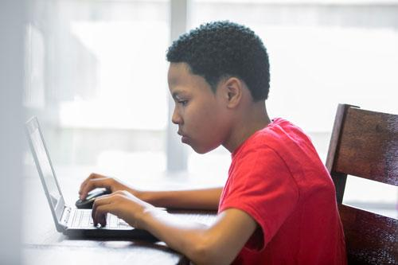

**Online Tutoring**

**Wednesdays & Thursdays,  
August 30, 2023 - May 30, 2024\***  
5 p.m. - 7 p.m.

30-minute one-on-one sessions in reading and math.

Desktop computer or laptop with internet, video and audio capabilities required.

To participate in online tutoring, please schedule an appointment each week through the Virtual Tutoring Portal.

[Register for a Virtual Tutoring Appointment](https://virtualtutor.mdpls.org/)

Important Reminders for Parents/Guardians

* Review and agree to the program guidelines on the online appointment request form.
* Check your Virtual Tutoring Portal or email for the Zoom session confirmation.
* Communicate tutoring needs with the assigned tutor in advance.
* Administrators may adjust virtual tutoring appointment times based on weekly availability and individual student needs.

Important Reminders for Students

* Test the access to your Zoom session and login 5 minutes early from your appointment time.
* Work in a quiet place and have learning materials (pen, pencil, paper) ready.
* All online sessions are recorded.

***\*Excluding November 18, 22, 23 and 25 (Thanksgiving), December 23-30, January 3-13 (Winter Break) and March 23-30 (Spring Break)***

[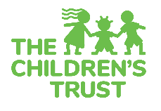](https://www.thechildrenstrust.org/)

*The Homework Help & Tutoring Program is funded in part by The Children's Trust. The Children's Trust is a dedicated source of revenue established by voter referendum to improve the lives of children and families in Miami‑Dade County.*

**In-Person Tutoring**

**Saturdays,  
September 2, 2023 - June 1, 2024\***  
10 a.m. - 1 p.m.

60-minute group sessions in reading, math and science.

Available at 29 library locations.

For more information, contact your preferred participating location.

[Reading Tutoring Library Locations](https://www.mdpls.org/tutor#collapseOne)

[Math Tutoring Library Locations](https://www.mdpls.org/tutor#collapseTwo)

[Science Tutoring Library Locations](https://www.mdpls.org/tutor#collapseThree)

**Helpful Links**

[Library Resources for Children](https://www.mdpls.org/children)  
Fun learning tools, Accelerated Reader Bookfinder, educational games and more!

[Library Resources for Teens](https://www.mdpls.org/teens)  
Book lists, research tools, volunteer opportunities and more!

[Online Learning & Training](https://www.mdpls.org/learning)  
Access to tutor.com, ABCmouse.com, LinkedIn Learning and more!