**Make Elephant Toothpaste**

[elementary school](https://www.munchkinfunathome.com/fun/category/elementary+school)*[preschooler](https://www.munchkinfunathome.com/fun/category/preschooler)*[toddler](https://www.munchkinfunathome.com/fun/category/toddler)*[stem](https://www.munchkinfunathome.com/fun/category/stem)

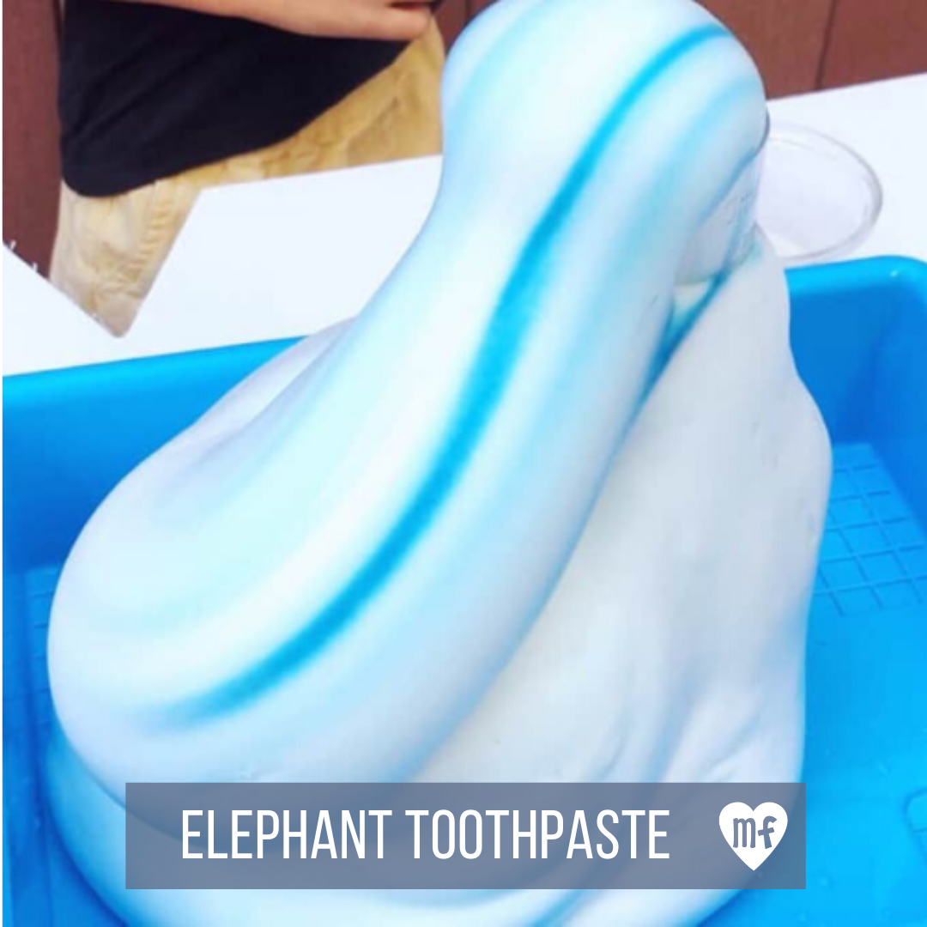

**Materials**

* 12ox plastic bottle
* Yeast
* Hydrogen peroxide (3%)
* Dish soap
* Warm water
* Baking soda

**Directions**

1. Add dry yeast to warm water and wait a few minutes until it becomes frothy.
2. Pour 2 inches of hydrogen peroxide into the bottle.
3. Place bottle on baking sheet.
4. Squeeze in a good squirt of dish soap.
5. Pour in yeast solution (3 tablespoons).
6. Watch

**What’s Happening**

Yeast contains an enzyme called Catalase that breaks down hydrogen peroxide (H2O2) into oxygen gas and water. The oxygen gas gets trapped by the soap, and you get a large foamy solution that squirts out of the top of the bottle.

adapted from [Imagination Station Toledo](https://www.imaginationstationtoledo.org/educator/activities/elephant-toothpaste)

**Ice Cream in a Bag**

[elementary school](https://www.munchkinfunathome.com/fun/category/elementary+school)*[preschooler](https://www.munchkinfunathome.com/fun/category/preschooler)*[toddler](https://www.munchkinfunathome.com/fun/category/toddler)*[stem](https://www.munchkinfunathome.com/fun/category/stem)

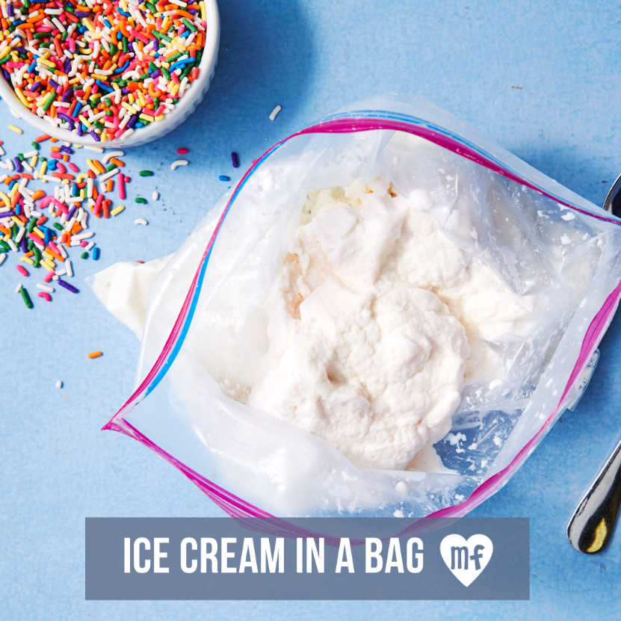

**Materials**

* 1 quart plastic bag, 1 galloon bag
* 1 cup half and half
* 2 tbsps granulated sugar
* 1/2 tsp vanilla extract
* 1/3 cup salt

**Directions**

1. Mix half and half, sugar and vanilla in a bag
2. Push out air & seal bag
3. Fill a galloon plastic bag with 3 cups of ice and 1/3 cup salt
4. Place the smaller bag inside and seal. Shake vigorously for 5 minutes.
5. Remove the inner bag and add your favorite toppings.

adapted from [The Dairy Alliance](https://thedairyalliance.com/blog/3-fun-milk-science-experiments/)

**Magic Mud**

[elementary school](https://www.munchkinfunathome.com/fun/category/elementary+school)*[tween/teen](https://www.munchkinfunathome.com/fun/category/tween%2Fteen)*[preschooler](https://www.munchkinfunathome.com/fun/category/preschooler)*[stem](https://www.munchkinfunathome.com/fun/category/stem)

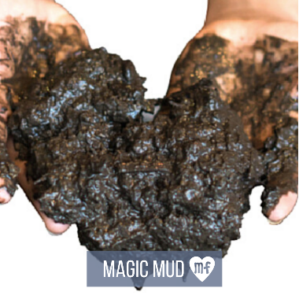

**Materials**

* Soil/dirt
* Water
* Baking soda
* Vinegar
* Squirt guns
* Play bin
* Optional mix-ins: Food coloring, glitter, etc

**Directions**

1. Mix equal parts soil & baking soda in basin
2. Slowly add water and mix. Slowly add more water until you get your desired consistency
3. Add optional mix-ins
4. Give kids squirt bottles filled with vinegar & watch the mud magically explode

adapted from [Growing a Jeweled Rose](https://www.growingajeweledrose.com/2013/05/play-recipes-magic-mud.html#more)