**4 Great Kids Nonfiction Books Celebrating Animals**

[preschoolers](https://www.munchkinfunathome.com/fun/category/preschoolers)*[toddlers](https://www.munchkinfunathome.com/fun/category/toddlers)*[elementary school](https://www.munchkinfunathome.com/fun/category/elementary+school)*[tweens/teens](https://www.munchkinfunathome.com/fun/category/tweens%2Fteens)*[books](https://www.munchkinfunathome.com/fun/category/books)

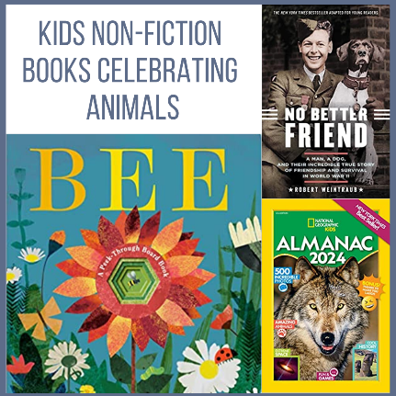

Animals are fascinating and cuddly. Spending time with classroom pets, visiting a zoo or snuggling with a dog can build connections and empathy. These nonfiction stories teach us all about remarkable animals in our world. .…

[**Forest: A Pop Up Surprise**](https://amzn.to/3nZiRQM) by DK. Explore the lift-the-flap pages to learn about the forest habitat and the animals who live there. Little readers will love learning about slugs, ants, deer and foxes in this adorable book. Recommended for **infants**.

[**Bee: A Peek-Through Board Book**](https://amzn.to/430m1mp) by Britta Teckentrup. Follow a bee's  journey through this beautiful peek-through board book. From pollinating plants to buzzy hives, readers will discover fun facts. Recommended for **toddlers**.

[**National Geographic Kids Almanac 2024**](https://amzn.to/3o2hv7T) by National Geographic Kids. Discover new countries, cute animals and scientific discoveries in this great almanac.  Facts, maps and photographs will inspire future explorers. Recommended for **elementary schoolers**.

[**No Better Friend: Young Readers Edition: A Man, a Dog, and Their Incredible True Story of Friendship and Survival in World War II**](https://amzn.to/3pGB2eE) by Robert Weintraub. Learn about World War II through this amazing story about Frank Williams, a radarman in Britain's Royal Air Force, and Judy, a loyal dog who helped him survive. Recommended for **tweens**.

**4 Kids Books Celebrating Earth Day**

[preschoolers](https://www.munchkinfunathome.com/fun/category/preschoolers)*[toddlers](https://www.munchkinfunathome.com/fun/category/toddlers)*[elementary school](https://www.munchkinfunathome.com/fun/category/elementary+school)*[tweens/teens](https://www.munchkinfunathome.com/fun/category/tweens%2Fteens)*[books](https://www.munchkinfunathome.com/fun/category/books)

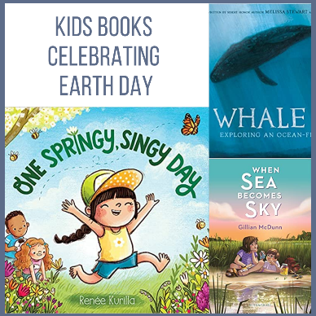

More than a billion people celebrate Earth Day and its focus on protecting the environment from things like pollution and deforestation. Join the movement with these four great books…

[**One Springy, Singy Day**](https://amzn.to/3KnCCZt) by  Renée Kurilla. Enjoy the cheerful and energetic adventure of a "springy, singy, squeezy" child. Recommended for **infants**.

[**Habitats of the World**](https://amzn.to/3UoeUku) by DK. Readers can explore the diverse animals, habitats and plants throughout the planet Earth - from the Arctic to Austrailia. Recommended for **toddlers**.

[**Whale Fall: Exploring an Ocean-Floor Ecosystem**](https://amzn.to/3MvCgCO) by Melissa Stewart. When a whale dies, its humongous body sinks to the ocean floor. For the next 50 years, its body provdes nourishment for deep-sea creatures. A great book about life cycles. Recommended for **elementary schoolers**.

[**When Sea Becomes Sky**](https://amzn.to/3KLvB6k) by Gillian McDunn. Bex and Davey live on Pelican Island, where a drought is affecting the salt marsh. When a statue appears in the water, the siblings embark on a mystery that might save their special place. Recommended for **tweens**.

**4 Kids Books Celebrating Sports & Outdoors**

[preschoolers](https://www.munchkinfunathome.com/fun/category/preschoolers)*[toddlers](https://www.munchkinfunathome.com/fun/category/toddlers)*[elementary school](https://www.munchkinfunathome.com/fun/category/elementary+school)*[tweens/teens](https://www.munchkinfunathome.com/fun/category/tweens%2Fteens)*[books](https://www.munchkinfunathome.com/fun/category/books)

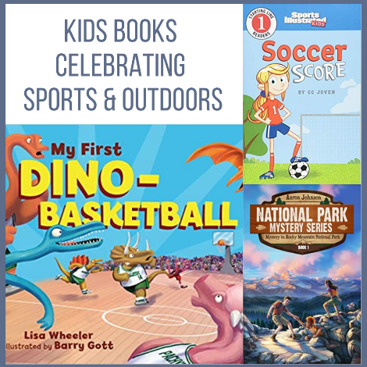

Kick, jump, pass and climb over craters in these sport-themed books…

[**My First Dino-Basketball**](https://amzn.to/3UyUUM1) by Lisa Wheeler. Watch dinos shoot, dribble and lob as they work together on the court. Recommended for **infants**.

[**Soccer Score**](https://amzn.to/415LYjE) by CC Joven. Grab your cleats! Throw on your jersey. This series is a great introduction for little readers to learn about soccer (and other sports). Recommended for **toddlers**.

[**It's a Numbers Game! Baseball**](https://amzn.to/4179jSi) by Jr. James Buckley. Dive into America’s pastime with facts, figures and fun. This book explores how math affects every aspect of baseball. Recommended for **elementary schoolers**.

[**Mystery In Rocky Mountain National Park**](https://amzn.to/3KAIPl2) by Aaron Johnson. Go deep in the heart of Colorado’s wild and rugged Rocky Mountain National Park with Jake and his friends. Will Jake, Amber and Wes solve the codes, riddles and clues that his grandfather has left behind? A great book about camping, survival skills and adventures. Recommended for **tweens**.